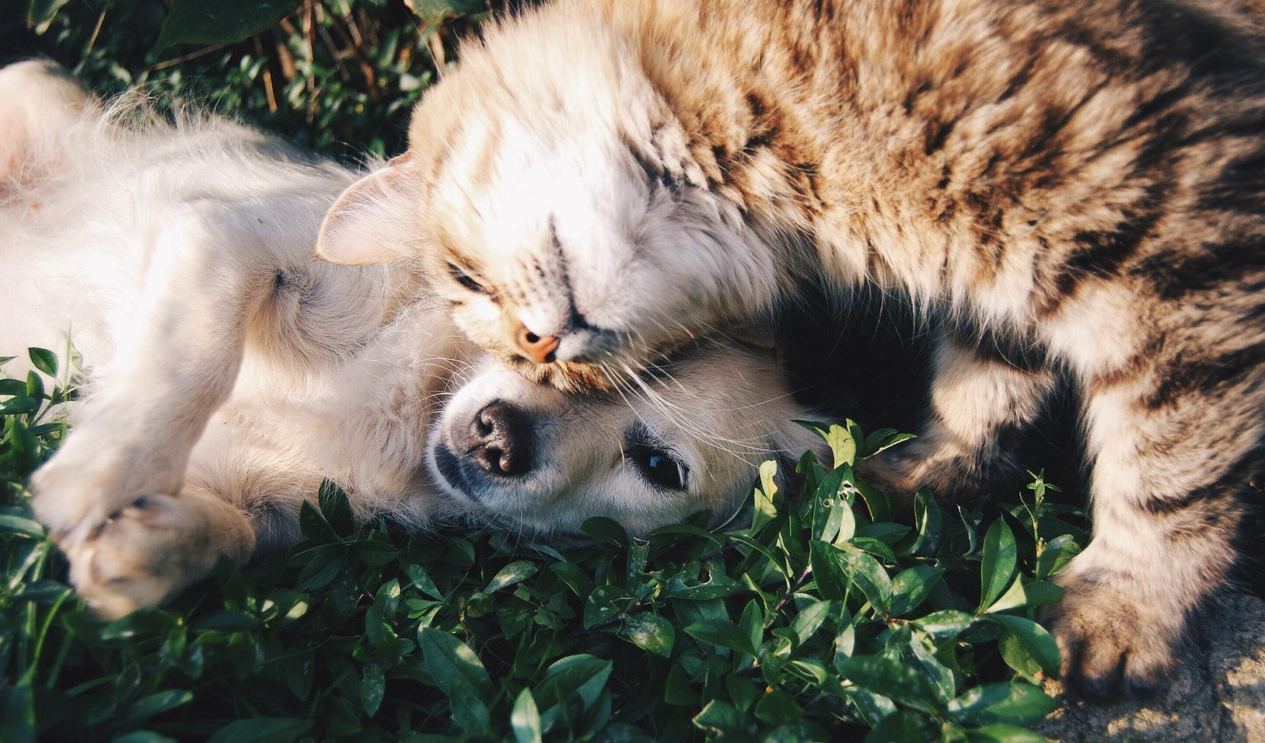
Photo via Pexels

FAQ About Helping Local Pets in Need

If the thought of someone abandoning their pet tugs at your heartstrings, you’re not alone. Most of us consider our pets members of the family! Pets help people and communities stay healthy and happy, so it’s important to protect our furry friends from harm and neglect.

Q1: What should I do if my neighbor is neglecting their pets?

A1: It’s heartbreaking to encounter an animal suffering from neglect or abuse in your community. Thankfully, there are several ways to help the animals involved in these situations.

- Help the owner place the animal in a better home.
- If you believe the animal's safety is in immediate danger, contact your local law enforcement.
- Document specific incidents and signs of cruelty that you have witnessed. Bring this evidence to your local authorities.

Q2: Can I start a nonprofit organization to help abandoned pets?

A2: Launching a non-profit is a great way to help the animals in your community. After coming up with an idea, cover your legal bases to lay the groundwork for your organization.

- Take inspiration from other animal welfare organizations to decide how your organization is going to help pets in need.
- Remember, all of the requirements involved in starting a business also apply to nonprofits.
- Learn what it takes to form an LLC in Georgia here: https://www.georgiallc.org.

Q3: What should I expect when fostering a pet?

A3: Before fostering a pet, make sure you know what to expect in terms of pet care requirements and household preparations.

- As a dog foster parent, you are expected to care for your foster animals as you would care for your own pets.
- Fosters dogs sometimes need to learn basic obedience and household rules.
- If you have other pets at home, make a plan to introduce them to your foster pet slowly and calmly.

Far too many pets are abandoned, neglected, or abused. If you want to get involved, help in any way you can! Whether you decide to foster a pet, volunteer at a local shelter, or start your own animal charity, supporting the pets in your community will be very rewarding. There are many ways to support the Newnan-Coweta Humane Society and improve the lives of pets in the community. Learn how you can get involved today!

